Day 55 Screenshots-

Run in terminal in VS code-

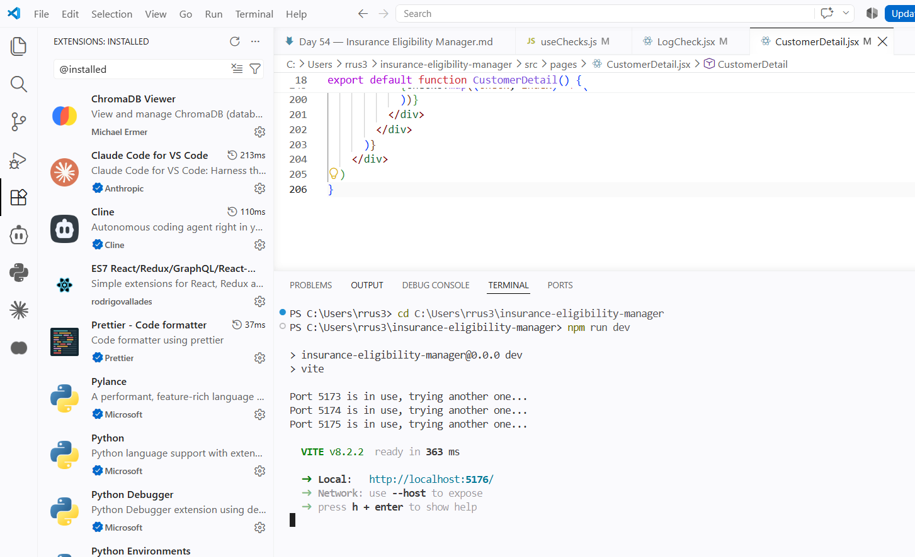

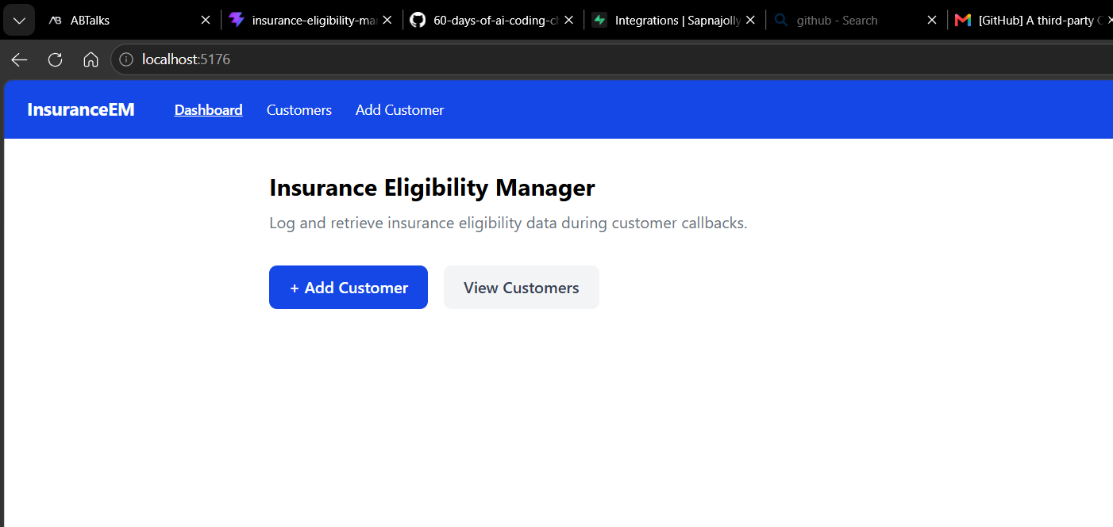
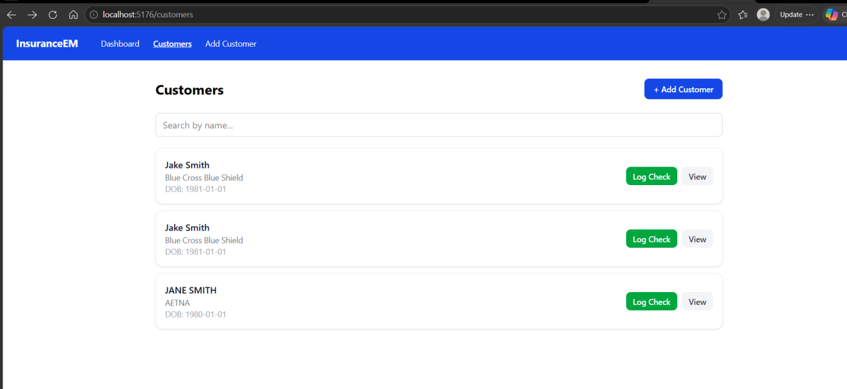

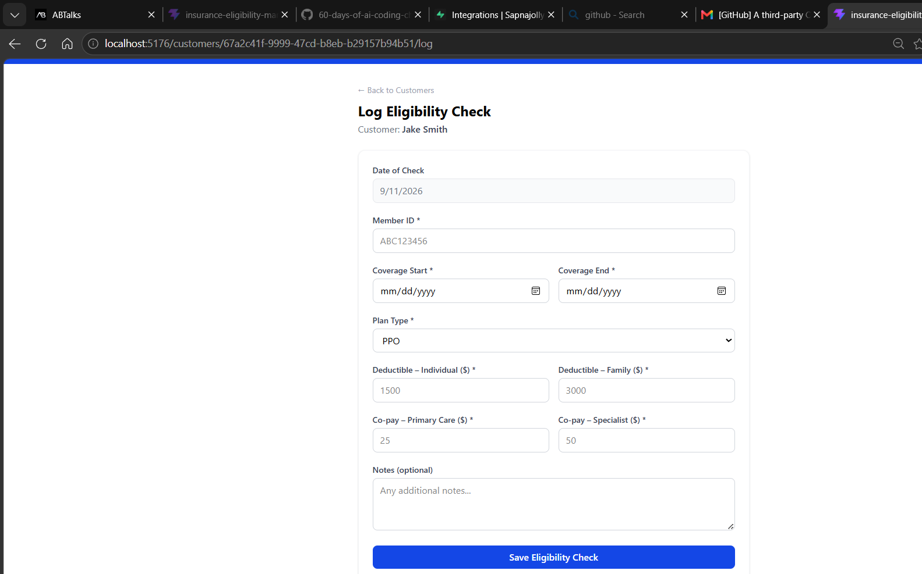

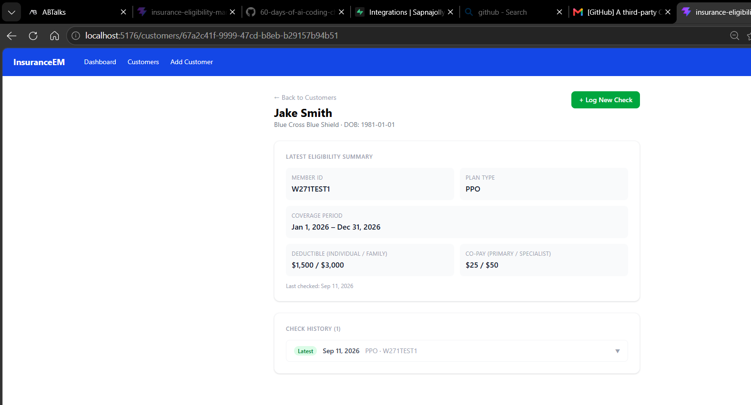

Days 4 and 5 are done. Everything works:
- Latest Eligibility Summary populating from real Supabase data
- Coverage period, deductible, co-pay all formatted correctly
- Check History with "Latest" badge
- "+ Log New Check" button in place

